

Digigital design lab

Exp 4: AND-OR-INVERTER (A-O-I) Gate Circuits







**AND-OR-INVERTER (A-O-I) Gate Circuits**

**Objective:**

Understanding the basic principle of combined logic.

**Introduction:**

AND-OR-INVERTER (A-O-I) gates consist of two **AND** gates and one **OR** gate and one Inverter(NOT) Gate.

The symbol of an( A-O-I) gate is shown in Fig(3-1) .

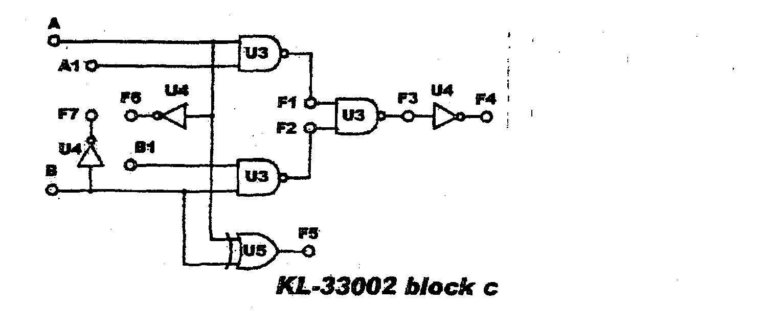

**The Boolean expression for the output F is:**

$F=\overline{AB+CD}$**­­ ……… Equation (1)**

Equation (1) can be converted into de Morgan’s theorem as:

**F=($\overline{A}$ + $\overline{B}$).($\overline{C}$ + $\overline{D}$)…….. Equation (2)**

Equation (1) is also referred to as **(Sum of Products)**

Equation (2) is also referred to as **(Product of Sum)**

Basically, the**(A-O-I)** gate is a “Sum of Products” logic combination.

**Required Equipment:** Digital Logic Lab; Module KL-33002( block c )

**Procedure:**

1. Connect inputs ( A, A1, B, B1) to Data Switches SWo, SW1, SW2, SW3 respectively and connect outputs F3, F4 to logic indicators L1, L2 .

2. Set B and B1 to'0', follow the input sequences for A and Al in Table(3-1) and record the output.

**Does F3 act as an AND gate between A and A1?**

3.When B=B1 = '1', Does F3 act as an **AND** gate between A and A1? (F3=A.A1) for B,B1 in the table(3-2) and record the outputs 4.When A=Al='0', following:

|  |  |
| --- | --- |
| F3 F4 | A1 A |
|  | 0 0  0 1  1 0  1 1 |

|  |  |
| --- | --- |
| F3 F4 | B1 B |
|  | 0 0  0 1  1 0  1 1 |

Table(3-2)

Table(3-1)

**Does F3 act as an AND gate between B and B1 ?**

5. When A and A1 ≠ '0', Does F3 act as an AND gate between B and B1

6. Follow the following table and record the output?

**Does F3 equal to (A.Al + B.B1)**

|  |  |  |  |  |
| --- | --- | --- | --- | --- |
| F3 | B1 | B | A1 | A |
|  | 0 | 0 | 0 | 0 |
|  | 1 | 0 | 0 | 0 |
|  | 0 | 1 | 0 | 0 |
|  | 1 | 1 | 0 | 0 |
|  | 0 | 0 | 1 | 0 |
|  | 1 | 0 | 1 | 0 |
|  | 0 | 1 | 1 | 0 |
|  | 1 | 1 | 1 | 0 |
|  | 0 | 0 | 0 | 1 |
|  | 1 | 0 | 0 | 1 |
|  | 0 | 1 | 0 | 1 |
|  | 1 | 1 | 0 | 1 |
|  | 0 | 0 | 1 | 1 |
|  | 1 | 0 | 1 | 1 |
|  | 0 | 1 | 1 | 1 |
|  | 1 | 1 | 1 | 1 |

7. Implement the following equation and find the result

*F(x,y)* = $\overline{ x}+xy$

**Discussion:**

1.What logic does the A in A-O-I represent?

a. AND b. NAND c. OR

2. What is the output of an A-O-I gate?

a. $\overline{AB+CD}$ b. (A+B).(C+D) c. ABCD

3. ‘‘Sum of Products” is expressed as:

a. AB +CD b. (A+B).(C+D) c .ABCD

4. The abbreviation for ‘‘Sum of Products” is:

a. POS b. SOP c. PSO

5. A-O-I is basically a:

a. POS gate b. SOP gate c. Either

6. C= and D= for the output F= $(\overline{AB+CD})$ of an (A-O-I)gate, it is to a:

a.OR gate b. XOR gate c. NAND

7. What does the O in (A-O-I) represent.

a. ON b. OR c. OFF